Dear (Insert Family or Friend’s name here),

I wanted to thank you again for supporting me and my organization, Atlas, during THON 2017. Whether it was through donating or learning about our cause, you helped us to raise nearly $200,000, making us one of the top fundraising organizations for THON 2017. It was an incredible year for both Atlas and the THON community, and we are excited to continue fundraising and working hard to help end the fight against pediatric cancer.

THON volunteers continuously work to emotionally and financially support families whose children have or had a cancer diagnosis. Atlas has been lucky enough to share this journey with our four families throughout the years, all of whose kids are now cancer survivors because of THON. During THON weekend, we spent our time celebrating in the company of our four amazing children, Claire, Victoria, Amarie, and Samir. As a part of this organization, we are looking forward to what the rest of this year and THON 2018 have to bring and we are hopeful that you will once again be a part of our fight. This is an incredible cause that has made a difference in the lives of so many deserving people. In our effort to support them, we have the utmost appreciation for all of you who support us and it is something that will never go unnoticed.

If you would like to donate, you can make checks payable to the Penn State Dance Marathon, with Atlas 312 in the memo section. If you prefer, you can also donate online at www.atlasftk.org/donate.

“When we do things for ourselves, they die with us. When we do things for humanity, they live on forever”. I cannot thank you enough for your support!

(Feel free to include a personal blurb here)

For The Kids,
(Sign Name Here)

INCREASE THE IMPACT OF YOUR DONATION!

Donor Name:

________________________
Donor E-mail:

________________________
Donation Amount: $_________

Donation Amount: $_________

Date of Donation: ___/___/___

RECEIPT: Keep the first for your records and enclose the second with your donation!

Employee Matching
Your company may qualify to match the amount of your donation to THON. To see if your company matches donations, go to:

http://www.thon.org/donors/employeematching

Company Donations
You can also donate through your business and receive benefits such as tours, THON memorabilia, among many others!

To receive a packet containing corporate donor information, e-mail:

donor.alumni.relations@ atlasftk.org
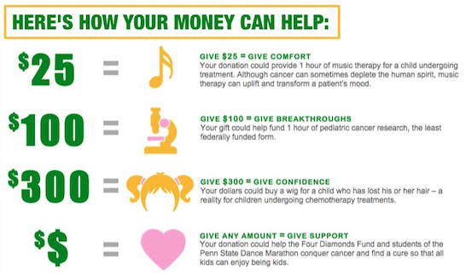

(Feel free to use this area to include pictures, a personal blurb, or a text box for “Why I THON”. These can help donors to see how close we are to the cause!)

Thank You For Supporting Atlas For The Kids!

